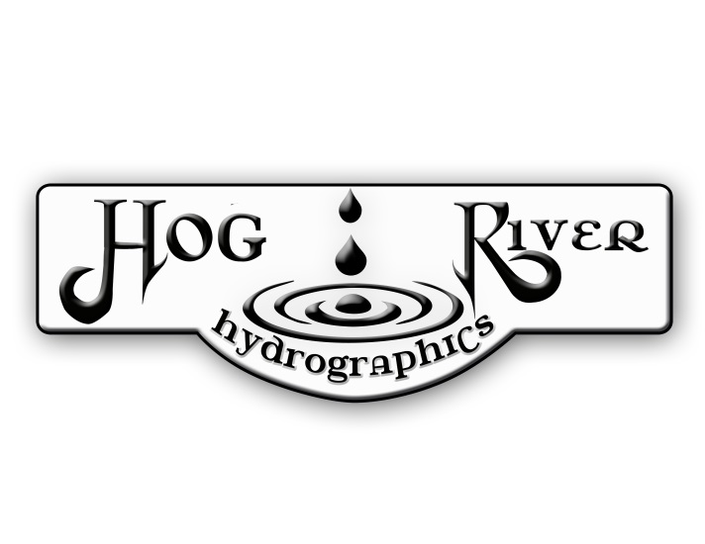
Customer Name: | Phone #:
Street Address: | Email:
City, State: | Zip Code:
Description of work: Include item description, base color, film name/#  If a non-stock film or custom order is requested, a 50% deposit for the job and additional fees may apply. | Base Costs:
 | Custom Request:
 | Subtotal:
Type of Finish:  Notes: | Discount:
Tax:

Total:

FOR FIREARMS ONLY:  Gun Make: Model #: | Deposit:
Serial #: | Amount Due on Invoice:
Some film choices or part configurations will require seams or areas that will remain unprinted. We will discuss this if it applies to your item; Hog River Hydrographics will keep the product's overall appearance in mind when laying out the areas to be processed. The seam placement will be decided by Hog River HG, unless noted to do otherwise. The hydrographic process requires the submerging of all parts into water. Hog River HG will not be responsible for damage to any parts due to being submerged in water. Firearms and Bows must be disassembled in order to be dipped. If not done by the customer, Hog River HG will have a 3rd party disassemble at the customer's cost or return the item to the customer for disassembling. They will not be re-assembled. Any Warning Labels, including stickers and riveted tags will be removed prior to processing. It is the customer's responsibility to replace all manufacturers’ warning labels. By signing below, you hereby authorize Hog River HG to process all shipped/delivered parts as specified on this form.
By emailing, mailing, faxing, or signing, you agree: it will act as your authorization for HRHG to begin work, all sales are final after 24 hours without contact for changes, and some items may not be covered by a warranty due to improper handling, normal wear and tear, as well as consumer negligence.
Signature: | Date:

